**Us5** [**iiid@gasssmail.com**](mailto:iiid@gasssmail.com)

**suqL@r61**

**What is Data Dog and what it does ?**

* Its a monitoring tool used for APM(application performance Management)
* It provides all types of monitoring at one place (DG = DataDog)
* It monitors (infrastructure,log management,APM, db monitoring, synthetic monitoring,incident management, ci visibility, real time monitoring, serverless,network monitoring, cloud SIEM , cspm , workload security, sensitive data scanner)
* Data collection types (DG agent, DG API, integrations)
* Agent collects the system data like (process queue, disk queue, cpu usage, memory breakdown, network traffic, disk usage in the form of metrics, events, logs,Traces) and sends to the DG website.
* To config monitoring alerts and sends notifications to any unfamiliar activity.

**DGAgent**

* Data Dog agent is a software which installed and runs in the hostmachine it collects the events & metrics and sends to the datadog website where we can monitor and analyze and performance data
* Initially sign up and download the agent and give the API key and the reporting website datadog.
* We can install the agent via GUI or via CLI (cmd or powershell)
* Agent acts as a middle ware between the application and the website
* Upon making any changes like any integrations or installations a restart of agent is required
* Main components are (collector (15 sec) and forwarder)
* Main configuration file stores in the windows path of file (datadog.yaml)
* We can download the agent from the datadog website under the integrations section.

**Customization**

* Tags are the way of adding dimensions to datadog telemetry so that they can be filtered aggregated and compared and datadog visualized.
* We can customize the DG Dashboard and its hostmaps, integrations and graphs, app metrics and Traces and logs as well.
* Error code 200 (ok) 200(sucessful)404 (Not found) 400(bad request)500(internal server error)
* We can perform appropriate user defined customization settings in every aspects in apps,dashboard, timeframe,graphs,metrics, infra list,hosts, APM, logs,custom tags & filters, export, and share as we like
* A software integration is the process of combining the two separated isolated software pieces to work together.
* Metrics explorer gives you the graph and Metrics summary give the general info
* Metric types are (count, rate, gauge, distribution)

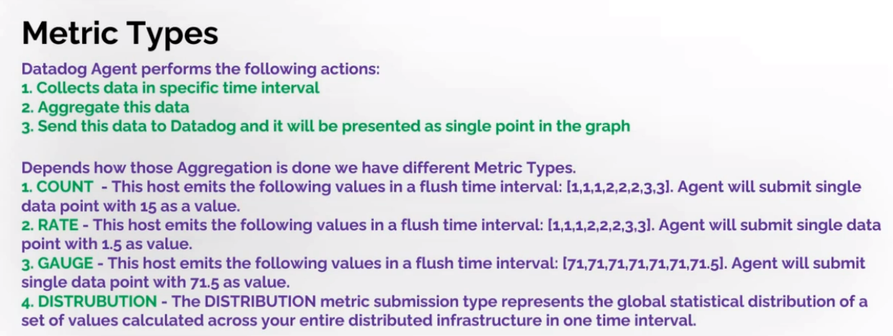

**APM Tracer Client**

* .Net Tracer is a software which is used to collect the traces
* DG>>APM>>introduction>>hostbased>> choose the language download and install the software and make the changes in the powershell cmd and paste it after the installation & restart the application & agent.
* Then in the APM section we can able to see the services and server Map and error and error traces…
* APM services in website we can see(request, latency, errors, total time spent,deployments,Endpoints Host and .net runtime metrics)
* We can customize these and can add severity and export and share, Timeframe
* Span summary & Traces can be seen in the end point dashboard
* Flame graph, span list, Trace Map can be seen by clicking on any traces in the end point or on queries dashboard
* APM services in DB we can see(request, latency,latency distribution, errors, queries, Host and .net runtime metrics)
* APM service Map: give the info & pictorial representation abt how different services communicate with each other
* Traces: which gives us all transactions in our application we can see(request,latency,error & Traces Table)
* We can customize the Trace data table as we like by applying the filter for the facets.
* We can add a new facets or we can add column from the flame graph >>Tags section
* These facets are only visible for only the future calls.
* Span list contains the info about the resources of and the db server (sql)
* Flame graph consists of the (default tags, infra,metrics,logs,error,process,network,code hotspots)
* Error Tracing gives in details info about the errors (APM>>Error tracing)
* APM profiling (install profiling software >>restart agent) then APM>>profile search

**How to send custom tags from .NET applications to Datadog?**

We should follow the below steps:

1. Open Nuget Package Manager for your solution and search for"Datadog Trace" and install it.

2. Now you have access to Tracer object in your app, and you can Set Tags/Metrics/Exceptions to your transaction which will be

submitted into Datadog.

Tracer.Instance.ActiveScope.Span.SetTag(key,value);

Tracer.Instance.ActiveScope.Span.SetException(ex);

**Note**:APM tracer in your host and Datadog Tracer in your application needs to be with the same version to be able to send tags, metrics

* Creating new dashboards and customization of these dashboards widgets, where we can import & export dashboards as well
* We can also customize it by edit template variables (we can use it as service token) to see the applied changes
* The two main dashboard types (screenboard & Timeboard)

**Monitors**

* Monitors>>Manage Monitors>>choose the categories(host)>>add monitor>>
* Alert condition (check alert–(host stops reporting) cluster alert–(when % of host stops reporting))
* We can create n number of monitors as we like depends on the criteria, we can set the threshold or alert conditions and the notification alerts (email) we can customize the monitors as we like
* Suggested monitors can be seen (APM>>services>>open any monitor >>below we can see suggested Monitors>>simply enable it)  
  We can also see these suggested monitors in the integrations>> monitors tab.
* Monitors>>manage monitors>>select any monitor and we can mute it for a time frame
* Triggered monitors >> these can be seen the alerts that has been triggered so far
* Schedule downtime >> where all the alerts will not be sent and we can schedule the time duration along with the notification alerts.

**Slack Integration**

* In slack create a new workspace and a channel.
* IN DG integration>>search slack>> in config connect to slack >>allow the permission>>filter the channel name .
* Monitor>>manage monitor>> select the monitor >> edit>>in the notification alerts>>choose the slack >> Test and save

**PagerDuty Integration**

* Pagerduty is a platform used for the incident management
* Create a 14 days free trail account in pagerduty and provide the service name as our application or our service name in the APM.
* IN DG >> interagtions>>pagerduty integration>>alert & connect pagerduty>>connect dg with the service region>>sign in >>click on servicename>>select the servicename>>connect
* Pagerduty>>servicename>>integrations>> reload
* Monitor>>manage monitor>> select the monitor >> edit>>in the notification alerts>>choose pagerduty_servicename >> Test and save
* We can check the Triggered alert in the pagerduty>>services>>triggered >>open >>resolve.

**What is a Synthetic Monitoring?**

* Synthetic monitoring or synthetic testing is an application performance monitoring practice,where we perform the actions which we think users/clients will do with our application.This could be achieved using automated series of request on our business transactions and API endpoints.

**Which metrics we track in synthetic Monitoring?**

* 1. Response Time(from server to the client)
* 2. Latency(from request to response end)
* 3. Load Time(whole page load time with all files)
* 4. System and Network Resources(CPU, Memory,HD)

**Use cases**

1. To see is our Application still running and alive?(Reachability and Availability)

2. Test new features before launching

3. To monitor web page speed and load times(application performance and availability)

4. Monitor third-party services and APIs

5. Identify browser or device-specific issues

6. Ensure SLA compliance

7. Reduce mean time to resolution(MTTR)

**Datadog API Test**

* In DG>>UX Monitoring>>Synthetic Monitoring>>create API Test
* Fill the details for the API test (URL, assertions, locations, test frequency, alert conditions,config monitor, set permissions) >> create
* The request types are (Get,post,put,delete,patch,head, options)

**Browser Test**

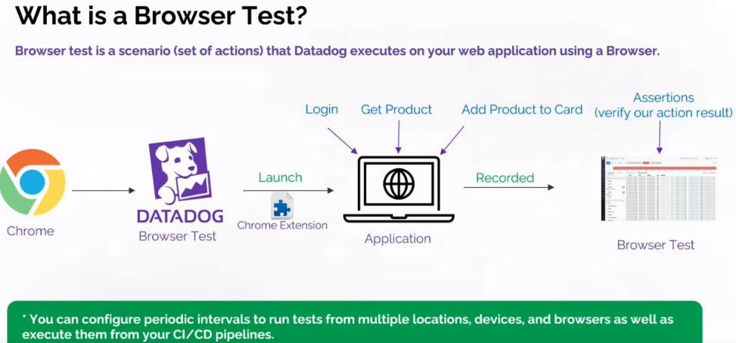

* In DG>>UX Monitoring>>Synthetic Monitoring>>create Browser Test
* Fill the details for the Browser test (URL, locations, test frequency, alert conditions,config monitor, set permissions) >> add the chrome extension >> do the changes on the url as you like
* It records in the step wise >> where we can customize it by adding assertions and many other options as required>>save and launch.

**Log Management System (LMS)**

* Log Entry : its a timestamp documentation of the event, which stores the event logs with timestamps for the system and the application.

Type of Log:( warn,Error,info & debug)   
Additional info : user info & API info

* All these Log Entry are stored in a file called LOG FILES
* LMS is a software solution that involves gathering, processing,storing and analyzing log data from our applications.

LMS helps us:

-Pinpointing areas of poor performance.

-Assessing application health and troubleshooting.

-Diagnosing and identifying the root cause of application installation and run-time errors.

**How to save logs in Datadog?**

* We use a logger object which is used to log messages for a specific system or application component.
* Data logging is the process of collecting and storing data over a period in order to analyze specific trends or record the data-based events/actions of a system, network or IT environment.

For different languages Datadog offers different logger solutions.

.NET:Serilog,log4net, NLog and Microsoft.Extensions.Logging

Java:Log4j.Log4j 2,Logback.

**How to Log data using Nlog**

**Steps:**

1. Datadog Agent-we need to enable logs in datadog.yaml file (logs_enabled:true)

2. Create"csharp.d"folder in Datadog\conf.d with a conf.yaml file inside

3. Create the empty Datadog.log file

4. Application changes-install Nuget Package for NLog

5. Configure NLog(using NLog.config)to save logs to a file and this file will be accessed from Datadog later

6. Go in Datadog Log Explorer and analyze your data

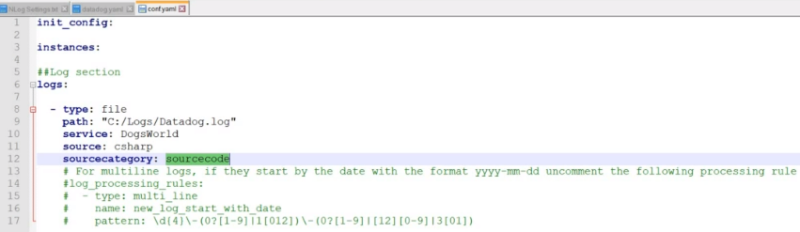

**NoteBook**

* Its a place or a page where you can add text elements (free text, headings, sub-headings, links,images,code blocks) & Graphs (top list, heat map,query value,timeseries) ..etc

**Notebook usages**

* **Runbook creation** -where we can describe how specific dashboard/monitor could be used for your team members
* **Investigation** -there is an exception in my application,and I am gathering graphs and notes and adding them in my notebook.So,everyone can see how investigation is going on and maybe someone can help me in my team.
* **Documentation**-you can add any kind of notes
* **Report**-to analyze data after specific time
* **Postmortem** -to document an incident root causes after it happened
* **Note**:The most powerful thing for Datadog Notebook is the collaboration.Your notebook is available for other members in your team so they can view it and add comments.When someone adds a comment, you can receive an email notification.
* In DG Notebook>>new notebook>>default name (username -current date & time)
* Customize the note books as you like and u can also set the notifications for the comments by clicking on the settings icon.
* Notebook >>Notebook list >>Template Gallery . we can use the existing templates or we can create a new custom template.
* We can also create a template from an existing notebook>>open notebook>>edit>>setting icon>>use this as a template.